November 15th 2024 at 12PM/Noon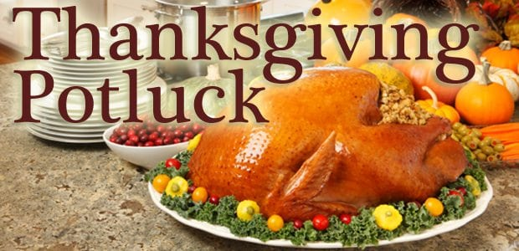
Turkey will be provided
Sign-up for Sides:
- Vegetables
- Potatoes
- Dressing
- Rolls
- Desserts

Cost is $10.00 per person
Please Contact the office to reserve your spot and let us know what you are bringing.

