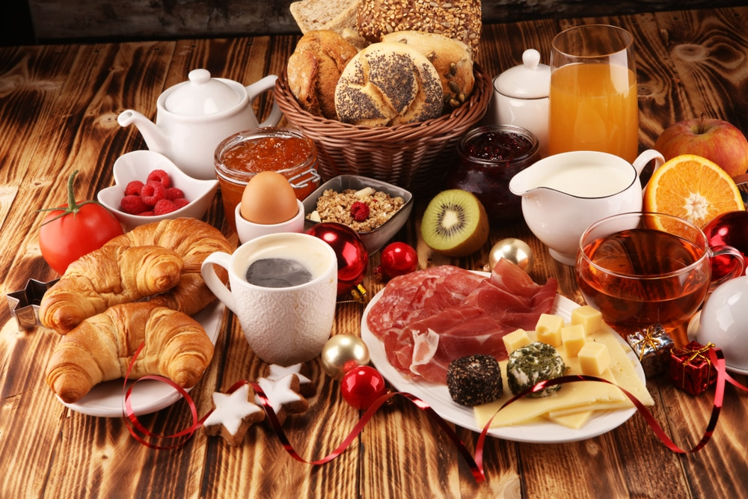
Sinto Center will provide:
- Bacon, Sausage & Ham
- Coffee, Tea & Juice
Members will sign-up to bring:
- Breakfast Casseroles, Quiches, Fruit & Salad
Toys for Tots & Quilt Raffle
Please call the office to reserve your spot and what you are bringing.
(509)327-2861

